Charter Assignment Execution steps:

1.git clone with the URL And set up project (https://github.com/kaarthikkvs/Creditrewardservice.git)

2.open with Intellij / other IDE

3.Grable to Auto import and build, project with Java17 and Spring boot 3.3.0

4.start the application

5.open the H2 Console

6.Tables should have created already

7.insert the table Data and change the Data accordingly like mentioned below

Script added in the src/main/resource – scripts.sql,

1. copy all the insert data of customers( atleaset one customer -101) and run for both tables (customer and transaction),
2. you may need to modify the date as mentioned below incase if you run after 6/22/2024 as per logic mentioned below

1.LastMonth Transaction Date = transaction_date should be within 30 day from the date when you run (current date – 30 days) logic can be seen in the Service implementation class (CustomerRewardServiceImpl.getRewardsByCustomerId)

2.Second Last Month date = Transaction_date should be current date - 60 days

3.3rd Last month date = Transaction_date should be current date - 90 days

Example:

If current Date is 6/15

Last month should be between 5/17-6/15 would better

Last Second month should be between 4/17-5/15 would be better

Last Third Month should be between 3/18-5/15 would be better

All 3 Month Timestamp can be seen in the log which we are printing, based on that you can change transaction_date incase needed

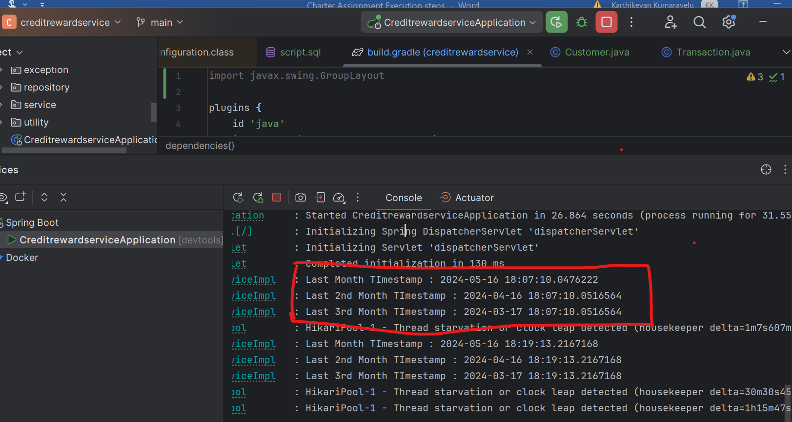

Insert commands to be executed in the H2Console

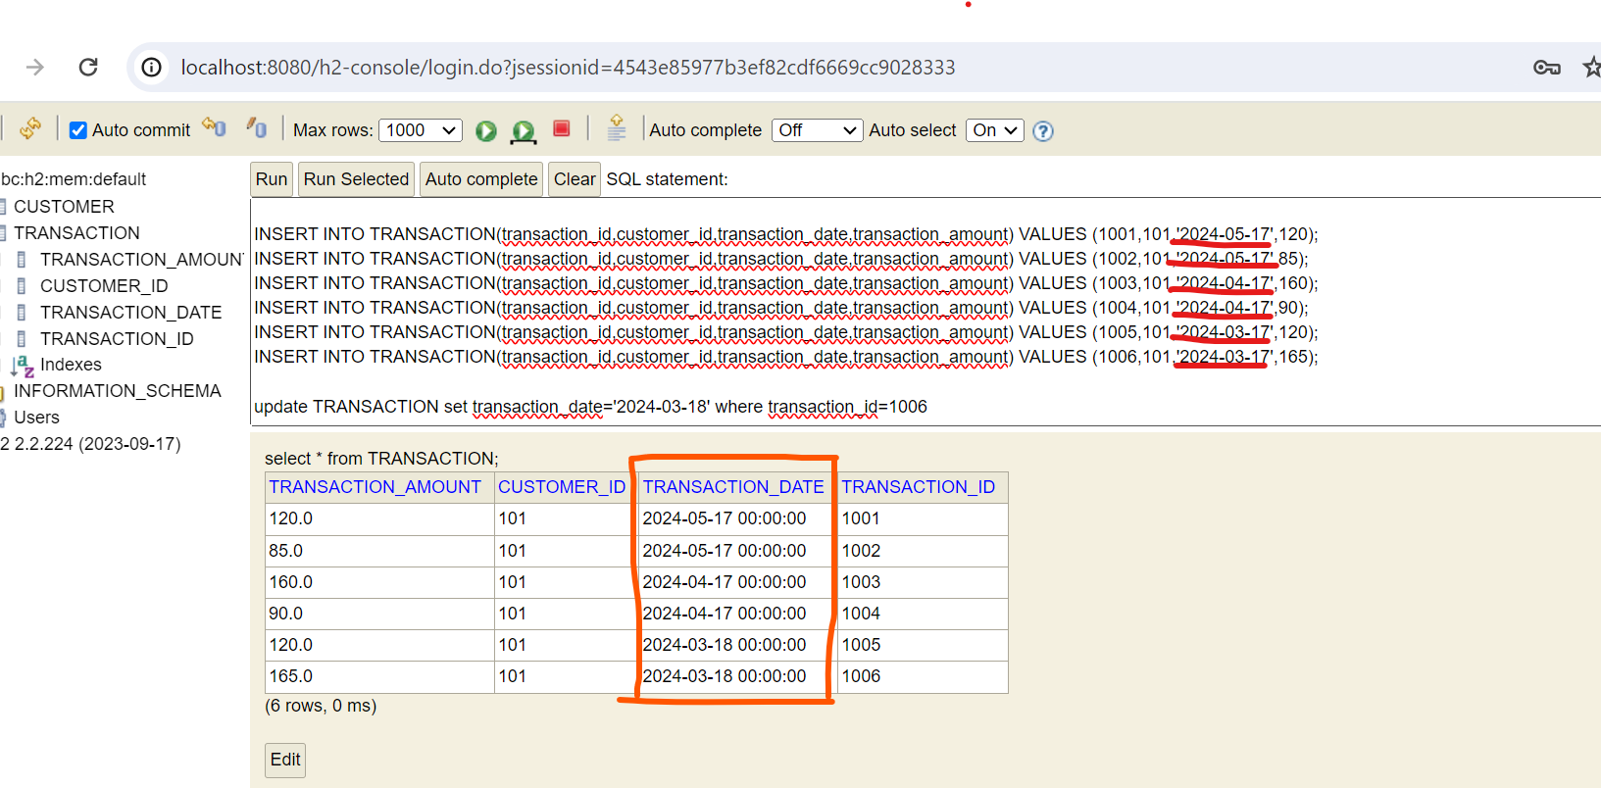

8.use the postman collection, import and run the endpoint

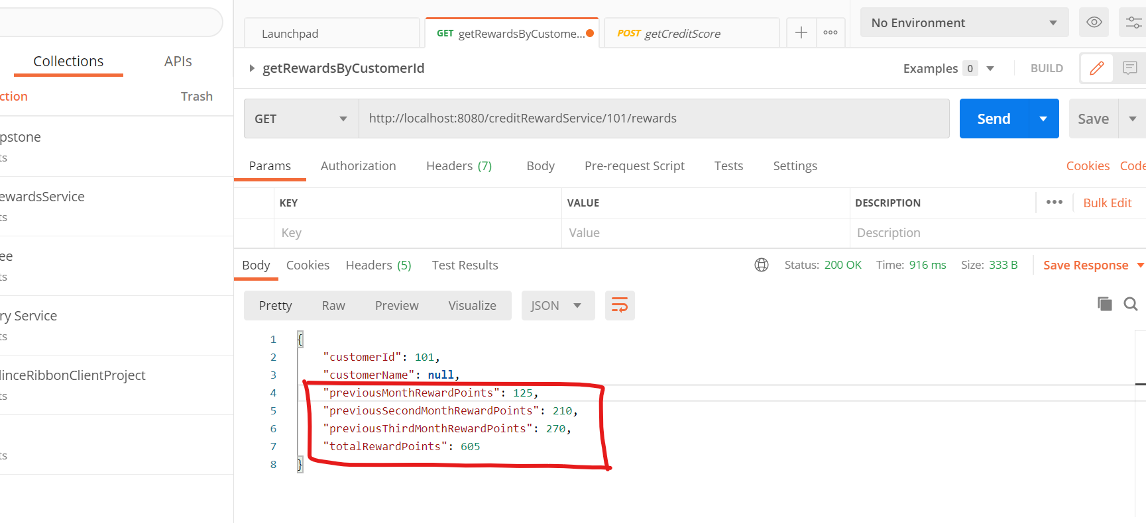

Above Example:

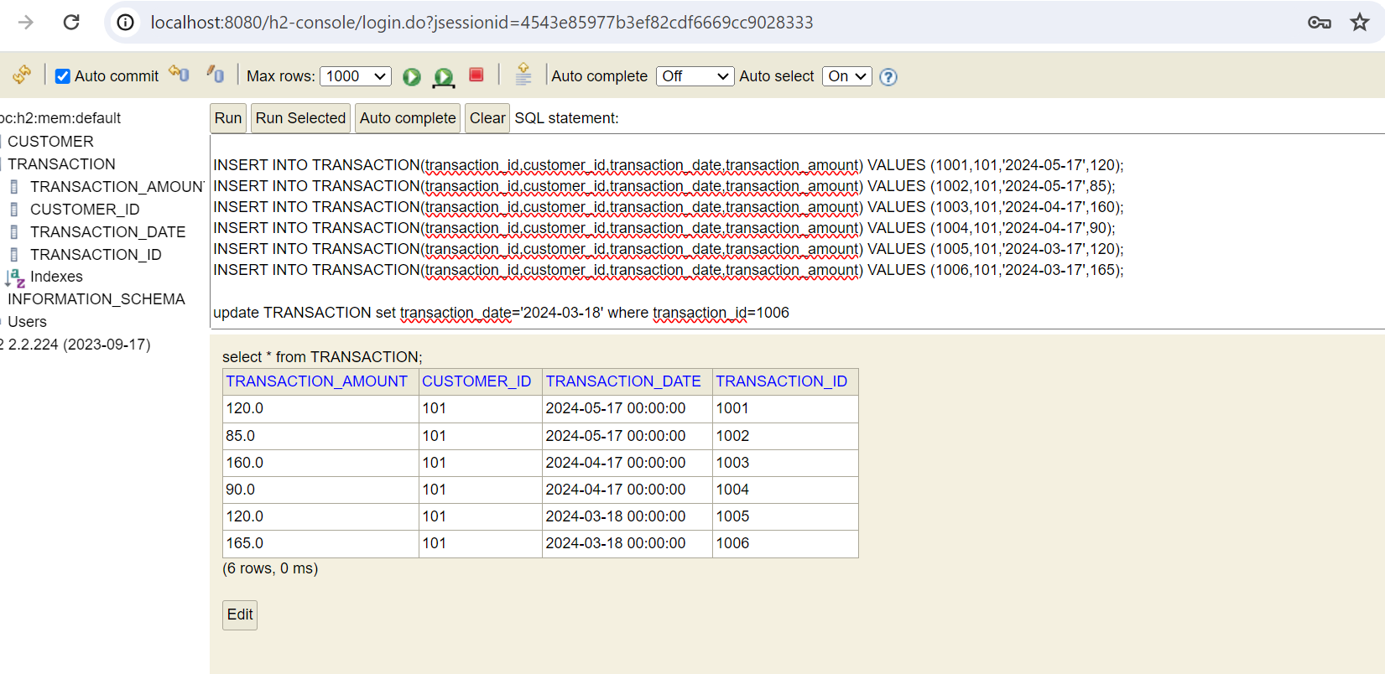

LastMonth points: two transactions

1.transaction_amount (120) – reward points 90 and transaction_amount (85) – reward points 35 – **previousMonthRewardPoints** :**125**

2.transaction_amount (160) – reward points 170 and transaction_amount (90) – reward points 40 – **previousSecondMonthRewardPoints**:**210**

3.transaction_amount (120) – reward points 90 and transaction_amount (165) – reward points 180 – **previousThirdMonthRewardPoints**:**270**

So, All 3 reward points total **totalRewardPoints:** **605** ,as you can see in the postman response above

These Project is initial Development for the Requirement and can be enhanced if needed